March | 2015
Sunday | Monday | Tuesday | Wednesday | Thursday | Friday | Saturday
1 | 2 | 3 | 4 | 5 | 6 | 7
 |  | Choir Rehearsal  Room 327 ASC  7:00PM | Rehearsal  Room 331 ASC  CW: 5:00PM  WS: 6:30PM | Jazz Band R.  5:30PM  The Fox On The Fairway  7:30 PM  North Lounge | The Fox On The Fairway  The North Lounge, WSCC  7:30 PM | The Fox On The Fairway  The North Lounge, WSCC  7:30 PM
8 | 9 | 10 | 11 | 12 | 13 | 14
Daylight Savings Time  The Fox On The Fairway  2PM Matinee  The North Lounge, WSCC |  | Choir Rehearsal  Room 327 ASC  7:00PM | Rehearsal  Room 331 ASC  CW: 5:00PM  WS: 6:30PM | Jazz Band Rehearsal  Room 331 ASC  5:30PM
15 | 16 | 17 | 18 | 19 | 20 | 21
 |  | St. Patrick’s Day  Choir Rehearsal  Room 327 ASC  7:00PM | Glenn Miller Orchestra  The Ramsdell Theatre, Manistee 7:30PM | Jazz Band Rehearsal  Room 331 ASC  5:30PM | First Day of Spring!
22 | 23 | 24 | 25 | 26 | 27 | 28
 |  | Choir Rehearsal  7:00PM  WSCC Jazz Band  7:30 PM  Center Stage | Rehearsal  Room 331 ASC  CW: 5:00PM  WS: 6:30PM | Last Day of Classes | 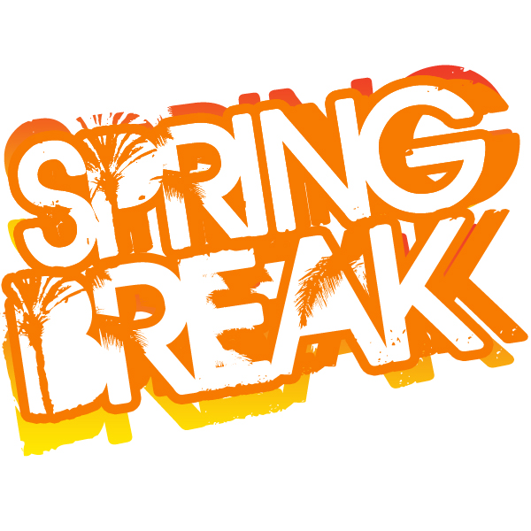  Spring Break | Spring Break
29 | 30 | 31
Spring Break | Spring Break | Spring Break

